6SENG002W Concurrent Programming

FSP Process Analysis & Design Form

Name | Thiloshon Nagarajah
Student ID | W1608489 / 2015298
Date | 06-01-19

1. FSP Process Attributes

Attribute | Value
Name | PRINTER
Description | A printer that can print up to 3 pages without refill.
Alphabet | {student.{acquire, print.paper, release}, technician.{acquire, refill, release}, waiting}
Number of States | 13
Deadlocks (yes/no) | No
Deadlock Trace(s) | N/A

2. FSP Process Code

FSP Process:
// CONSTANTS
const MAX_PAPER = 3
range PAPER_RANGE = 0 .. MAX_PAPER

// PRINTER FSM
PRINTER (N = MAX_PAPER) = PRINT[N],
PRINT[ papercount : PAPER_RANGE ] = (
when( papercount > 0) student.acquire -> student.print.paper -> student.release -> PRINT[ papercount - 1 ]
|
when( papercount == 0 ) technician.acquire -> technician.refill -> technician.release -> PRINT[3]
| waiting -> WAIT ), // Comment as required
WAIT = (waiting -> WAIT // Comment as required
).

3. Actions Description
A description of what each of the FSP process' actions represents, i.e. is modelling. In addition, indicate if the action is intended to be synchronised (shared) with another process or asynchronous (not shared). (Add rows as necessary.)

Actions | Represents | Synchronous or Asynchronous
student.acquire | Student taking control of the printer for printing | synchronous
student.print.paper | Student printing a paper | synchronous
student.release | Student leaving printer after printing job | synchronous
technician.acquire | Technician taking control of the printer for refilling | synchronous
technician.refill | Technician refilling papers of printer | synchronous
technician.release | Technician leaving printer after refilling | synchronous
waiting | Printer waiting for next operation | asynchronous

4. FSM/LTS Diagrams of FSP Process
Note that if there are too many states, more than 64, then the LTSA tool will not be able to draw the diagram. In this case draw small diagrams of the most important parts of the complete diagram.

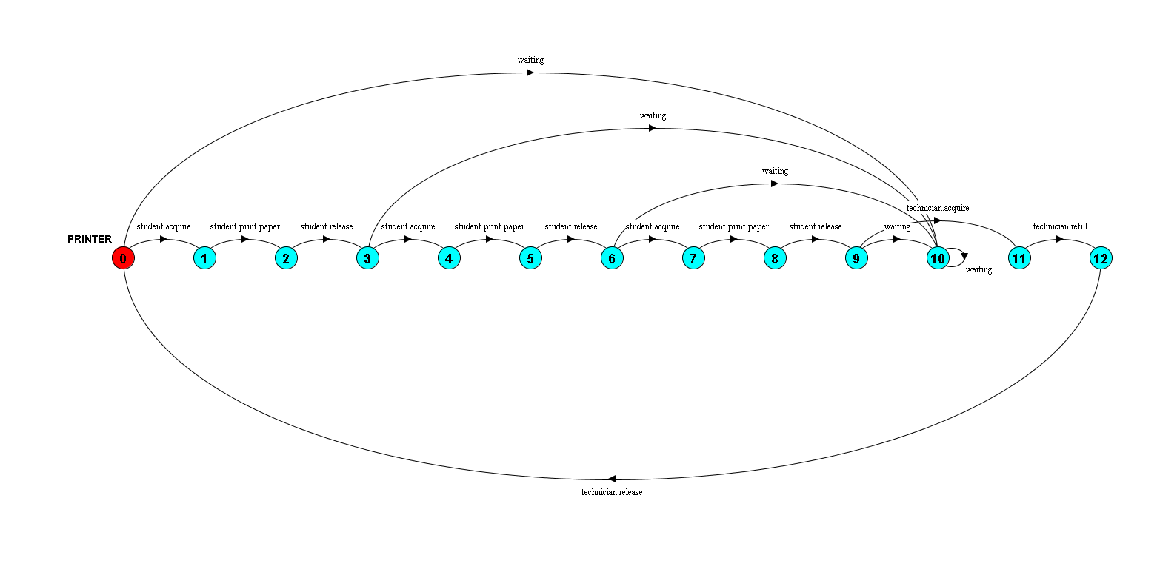

5. LTS States
A description of what each of the FSP process' states represents, i.e. is modelling. If there are a large number of states, then you can group similar states together &/or only include the most important ones. For example, identify any states related to mutual exclusion (ME) & the associated critical section (CS), e.g. waiting to enter the CS state, in the CS state(s), left the CS state. (Add rows as necessary.)

States | Represents
0 | Printer is ready to be used.
1, 4, 7 | A student has taken control of the printer.
2, 5, 8 | A printing job has been conducted by the student.
3, 6, 9 | Student has released the control and now printer is ready to be used.
10 | Printer is waiting for a job input.
11 | A technician has taken control of the printer.
12 | Technician has refilled the paper and printer is ready to be used.

6. Trace Tree for FSP Process
The trace tree for the process. Use the conventions given in the lecture notes.

